ACTIVITY: Maintenance of Rammer
Objective: - Safe maintenance of rammer for optimum use
Scope: - Blast Furnace Accessories
Ref.: -
Responsibility: - Engineer in charge & workmen on the job
PPE s to be used:
- Safety shoes, helmet, cotton cloth, goggles, hand gloves, and ear mask.
Aspect
Impact
Oil Spillage | Land contamination & Resource Depletion
Oil traced waste generation | Land contamination & Resource Depletion
Scrap Generation | Resource depletion
Hazards identified
Mechanical -
- Trapping of hand in between rammer parts.
- Fall of rammer while overhauling/connection.
- Hitting of hose on person during trials/operation if it is not connected properly/ due to improper welding / fitting.
- Sliding of rammer over the foot/ hand if not placed properly without safety chain over the stand
Physical –
- Impact of Air pressure
- Noise while taking trials/operation
Chemical Hazard - Gas poisoning due to improper flaring of flare stack. Usage of diesel /oil reacting with human skin during overhauling causes chemical poison and skin allergy.
Human behaviour:
1. Person working under alcohol.
2. Horseplay
3. Not using PPE s like helmet and dust mask and ear mask
4. Person bypassing work instruction and operating without care at very close distance from his feet

- Open the rammer with proper tools and tackles.
- Clean the parts and measure the dimensions of inside components and replace worn out components (if damaged).
- Check the throttle valve for proper functioning and the handle for its proper functioning.
- Tighten the threaded parts fully and tag weld to avoid loosening during operation & Fix side stud bolts(2 nos)
- Ensure side studs are provided to avoid loosening of rammer from threads. Full length threads tightening to be ensured of all connections.
- Ensure side studs have no cracks / disjoints to avoid unbalance during operation which would result in safety incidents, if side studs have problem same needs to replace immediately without taking chance.
- Ensure no air leakage from any connection
- Provide lock chain for hose connection area. Ensure to use fabricated clamp to fix rammer to hose. Chain to be welded to the clamp and clamp to be fixed at hose connection area on the metal piece of the hose (As shown in below photo). Ensure that the chain is not loose before the rammer trials are taken.
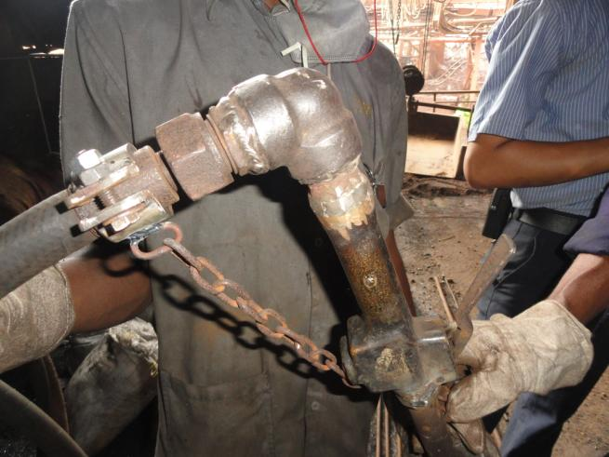
- While taking trial of rammer, hold the rammer vertically and stay away to avoid rammer does not hit the leg / shoes.
- Lubricate the machine with almost care to avoid spillage as per procedure WI/MAINT/93.
- Conduct trial with proper care.
- If ok, fix tag as over hauled & tested.
DOs
- Lock the threaded parts
- Ensure rammer hoses are locked with chain.
- Keep plugged / connected to prevent dust insertion.
- Ensure that threaded portions are fully tightened.
- Ensure that fabricated clamp is connected. Do not use jubilee clamps.
- Ensure that the chain is not loose.
Ensure that both the studs are present.
- Periodic check for hose clamp, stud, inspection of welding
Back
Don’t

- Check the rammer in open condition of any one of side stud.
- Operate the rammer in half air hose connected position.

Amendement Record
Date | Manual Section Ref. & Para | Brief details of Revision | New Rev.

Prepared By:  Area Engineer | Reviewed & Issued By:  Management Representative | Approved By:  Mechanical Head
Signature | Signature: | Signature:
Review Date: 12.12.22 | Review Date: 12.12.22 | Review Date: 12.12.22

